

#44/4, District Fund Road, Behind Big Bazaar, Jayanagar 9th Block, Bengaluru, Karnataka 560069

### SCHOOL OF COMPUTER SCIENCE & IT

**Bachelor of Computer Applications**

#### A Project Report On

*“Know Your Rent”*

Submitted in partial fulfillment of BCA (Internet of Things)

##### SUBMITT ED BY

**S Vikash Madhav *(18BCAR3012)***

**Sagarika Naik *(18BCAR3022)***

### UNDER THE GUIDANCE OF

**Dr. Kavitha R,**

Associate Professor,

Jain University,

School of CS and IT.

**Department of Bachelor of Computer Applications**

**Jain (Deemed-to-be University)**

#44/4, District Fund Road, Behind Big Bazaar, Jayanagar 9th Block, Bengaluru , Karnataka, 560069.



### SCHOOL OF COMPUTER SCIENCE & IT

**Bachelor of Computer Applications**

### CERTIFICATE

Certified that the project work entitled Know Your Rent carried out by Mr Vikash Madhav Sridhar 18BCAR3012, Ms. Sagarika Naik 18BCARR3022 a bonafide student of Jain University, in partial fulfillment for the award of Bachelor of Computer Applications in Data Analytics School of Computer Science and IT, Jain (Deemed-to-be) University, Bangalore, during the year 2020–21. It is certified that all corrections/suggestions indicated for Internal Assessment have been incorporated in the Report deposited in the department library. The project report has been approved as it satisfies the academic requirements in respect of Project work prescribed for the said degree.

**Guide-:**

**Dr. Kavitha R, Dr. M N Nachappa**

Associate Professor, HoD ,

Jain University, Department of BCA

School of Computer Science and IT. School of CS & IT.

**Name of the Examiner Signature with Date**

**1.**

**2.**

### DECLARATION

I/We hereby declare that the project work entitled “**Know Your Rent**” submitted to the Jain (Deemed-to-be) University, Bangalore during the year 2020-2021, is a record of an original work done by me under the guidance of Dr. Kavitha R , Associate Professor, Department of BCA, School of CS & IT and this project work is submitted in the partial fulfillment of the requirements for the award of the degree of Bachelor of computer applications in Data Analytics. The results embodied in this thesis have not been submitted to any other University or Institute.

Mr Vikash Madhav Sridhar

18BCAR3012

Ms. Sagarika Naik 18BCARR3022

### ACKNOWLEDGEMENT

It is not the completion of the project that is the most important but more so, the interaction of roles played by various people in the satisfactory completion of the same. We take this opportunity to express our deep gratitude and appreciation for all those who encouraged us to successfully complete the project.

With profound sense of gratitude and regards, we acknowledge with great pleasure the guidance and support extended by Dr. Eshwaran lyer, Dean, Jain Knowledge Campus, Bangalore. Dr. M.N. Nachappa, Head, School of Computer Science & IT, Jain University, Bangalore for their interest and motivation towards the completion of this project.

We are grateful to our Guide, Prof. Dr. Kavitha R , Associate Professor, Department of BCA, Jain University, Bangalore for her guidance arid valuable time spent with us towards the successful completion of its project.

We would also thank our parents, friends and non-teaching staff for their support in completing this project.

**LIST OF FIGURES:**

|  |  |  |
| --- | --- | --- |
| **FIGURE NO.** | **FIGURE NAME** | **PAGE NO.** |
| 1.1 | CSV File produced by data extraction. | 13 |
| 2.1 | Login Module | 14 |
| 3.1 | Admin table | 15 |
| 3.2 | Customer Table | 15 |
| 4.1 | Code Screenshot | 18 |
| 4.2 | Code Screenshot | 18 |
| 4.3 | Code Screenshot | 18 |
| 4.4 | Code Screenshot | 19 |
| 4.5 | Code Screenshot | 19 |
| 4.6 | Code Screenshot | 19 |
| 4.7 | Code Screenshot | 19 |
| 4.8 | Code Screenshot | 20 |
| 4.9 | Code Screenshot | 20 |
| 5.1 | Location w Apartment | 21 |
| 5.2 | Sellers in Bangalore | 22 |
| 5.3 | Agents in Bangalore | 23 |
| 5.4 | Amenities Provided | 24 |
| 5.5 | Carpet Area v Rent. | 25 |
| 6.1 | Website Homepage | 26 |
| 6.2 | User Login | 26 |
| 6.3 | Register User | 27 |

**ABBREVIATIONS**

|  |  |
| --- | --- |
| Abbreviations | Description |
| GUI | Graphical User Interface |
| HTTP | Hyper-Text Transfer Protocol |
| API | Application Programing Interface |
| XML | eXtensible Markup Language |
| IDE | Integrated Development Environment |
| RAM | Random Access Memory |
| ROM | Read-Only Memory |
| UI | User Interface |
| CSV | Comma-Separated Value |
| ER Diagram | Entity Relation Diagram |
| HTML | Hyper-Text Mark-Up Language |
| CSS | Cascading Style Sheet |
| AMD | Advanced Micro Devices |
| GB | GigaByte |

# TABLE OF CONTENTS

|  |  |  |
| --- | --- | --- |
| **SO. No** | **NAME** | **PAGE NO.** |
| 1 | Title Page | 1 |
| 2 | Certificate | 2 |
| 3 | Declaration | 3 |
| 4 | Acknowledgement | 4 |
| 4 | List of Figures | 5 |
| 6 | Abbreviations | 6 |
| 7 | Project Profile | 8 |
| 8 | System Environment | 9 |
| 9 | System Development Strategy | 11 |
| 10 | Data Dictionary | 12 |
| 11 | Data Flow Diagram | 13 |
| 12 | ER Diagram | 14 |
| 13 | Future Enhancements | 16 |
| 14 | Design and Screenshots | 20 |
| 15 | Testing | 25 |
| 16 | System Limitations | 27 |
| 17 | Bibliography | 28 |

## 1 Project Profile

### Project Definition:

Know Your Rent is a program, where we can check statistical data of the rents/ rates of various apartments for purchase, rent or lease in Bangalore. The program scrapes commonfloor.com for data and analyzes it to draw relevant conclusions. This program is not specific for apartments but can also be applied to independent houses in various places in Bangalore.

### Project Duration:

The project idea began with thinking about students going to different cities for education and how their accommodation is managed. This program was then designed to help students or employees who travel to Bangalore for work or studies to aid in their apartment searching process.

### Objective:

In the 21 century, as the working population increases, so do their incomes. Thus, we are also seeing a surge in rents/ rates of properties, houses, apartments. The purpose of this program is to know what owners are charging their tenants as rent or how much properties in different areas of Bangalore cost. We also check the amenities, seller, location and rent of the apartment.

## 2 System Environment

### Frontend Tool:

The frontend of the project was built using HTML, CSS and Javascript. For a user to use this program, all they would need is a functional web browser.

### Backend Tool:

But for the server, they’ll need the following:

##### Hardware requirements:

* + 1. Intel i5 7th gen and above or an AMD equivalent
    2. 3 GB - 5 GB ROM
    3. 8 Gb and above RAM

**Software Requirements:**

##### Any modern day operating system

A modern Operating System is one that supports python3 and other libraries mentioned below.

##### PyCharm or any Python IDE

PyCharm is an integrated development environment used in computer programming, specifically for the Python language. It is developed by the Czech company JetBrains.

An integrated development environment is a software application that provides comprehensive facilities to computer programmers for software development. An IDE normally consists of at least a source code editor, build automation tools and a debugger.

##### Python

Python's simple, easy to learn syntax emphasizes readability and therefore reduces the cost of program maintenance. Python supports modules and packages, which encourages program modularity and code reuse.

##### BeautifulSoup

Beautiful Soup is a Python package for parsing HTML and XML

documents. It creates a parse tree for parsed pages that can be used to extract data from HTML, which is useful for web scraping.

##### Matplotlib

Matplotlib is a plotting library for the Python programming language and its numerical mathematics extension NumPy. It provides an object-oriented API for embedding plots into applications using general-purpose GUI toolkits like Tkinter, wxPython, Qt, or GTK.

##### Pandas

pandas is a software library written for the Python programming

language for data manipulation and analysis. In particular, it offers data structures and operations for manipulating numerical tables and time series.

##### Requests

The requests module allows you to send HTTP requests using Python. The HTTP request returns a Response Object with all the response data (content, encoding, status, etc).

### Tools and Technologies:

##### The application has these 6 server side modules:

1. Connection: In this module, we establish connection with the website for scraping.
2. Extraction: Now that the connection is established, we extract the necessary data from that website.
3. Storing, We store the extracted information in a pandas dataframe, then we convert it into a CSV file.
4. Cleaning: We clean the extracted data by converting everything to lowercase and replacing missing values with 0.
5. Visualization: We used the cleaned extracted data to generate charts and graphs.
6. Database: We have a database to store client data for authentication purposes.

## 3 Design Methodology of Proposed Work

### 3.1 Stages:

**Stage 1:** The first objective was to successfully scrape data from commonfloor.com and clean it.

The first step included writing python code to scrape data from commonflood.com using BeautifulSoup, a python library that extracts data from HTML or XML code by dividing the attributes into trees. BeautifulSoup does this with existing HTML code that was extracted using requests, a python library that goes to the URL provided in the syntax parameter and retrieves the website’s entire HTML file.

**Stage 2**:The Second objective is to make a website to host all the visualizations drawn from our scraped data.

The website was made by using HTML, CSS and Javascript. The website hosts visualizations of Location wise apartment availability frequency, Sellers with high market dominance, Agents who are actively aiding sellers sell their apartments and occupants find their apartments in Bangalore. It also hosts graphs that show popular amenities in apartments in Bangalore and how an increase in carpet area affects rent. All of the above charts are available for 1, 2, 3 Bedroom, hall and kitchen apartments in Bangalore. The website has a login module, which in future can be used to send alerts to users whenever the website has new information, or a new article is published. Users can also request alerts as and when an apartment is available in a certain location in Bangalore.

**Stage 3:** Perform data analytics on the extracted data to generate graphs/ charts and upload it to our website.

The data extracted from commonfloor.com was used to generate the following visualization charts using matplotlib, a python library used to produce visualization charts: Location wise apartment availability frequency, Sellers with high market dominance, Agents who are actively aiding sellers sell their apartments and occupants find their apartments in Bangalore. It also hosts graphs that show popular amenities in apartments in Bangalore and how an increase in carpet area affects rent. All of the above charts are available for 1, 2, 3 Bedroom, hall and kitchen apartments in Bangalore.

## 4 Data Dictionary

### All Tables and Details (CSV files):

This Project uses Python files that generate a CSV file for each type of apartment, i.e, 1 BHK, 2 BHK and 3 BHK. The CSV files store the following data:

* + 1. Apartment Details
    2. Agents
    3. Rent
    4. Locations
    5. Sellers
    6. Carpet Area.

We then use these details to generate relevant charts/ Graphs.

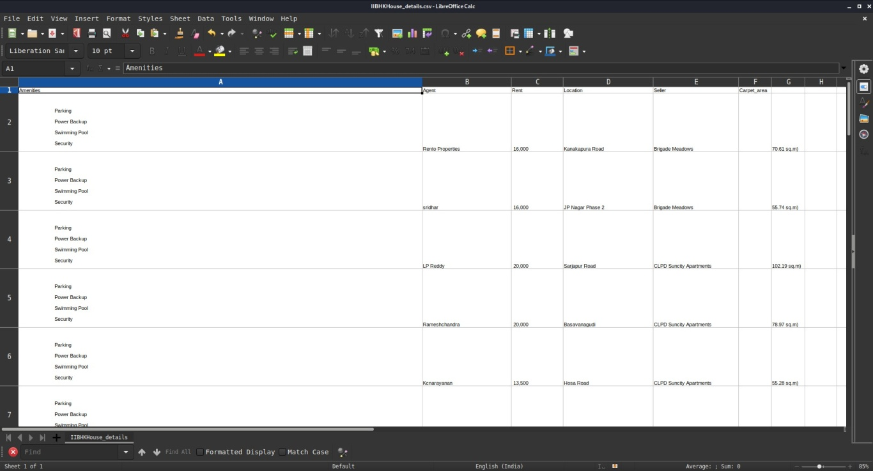

Fig 1.1 CSV File produced by data extraction.

## 5 Data Flow Diagram

### 5.1 Login Page. and data extraction:

This project hosts a login page for both customers and admins. With this, a customer can register themselves with our website for future notifications as and when new details are uploaded. Although this is a simple login page that is made using javascript text validation, in future this can be improved to support php and authenticate using database login. The database will contain two four tables. Admin table, Admin login details table, Customer table, Customer Login Details table, containing Admin ID and name, Admin ID and password, Email ID and name, surname and phone number, Email ID and password respectively.

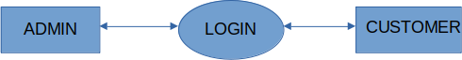

Fig 2.1 Login Module.

## 6 ER Diagram

### Admin Table ER Diagram:

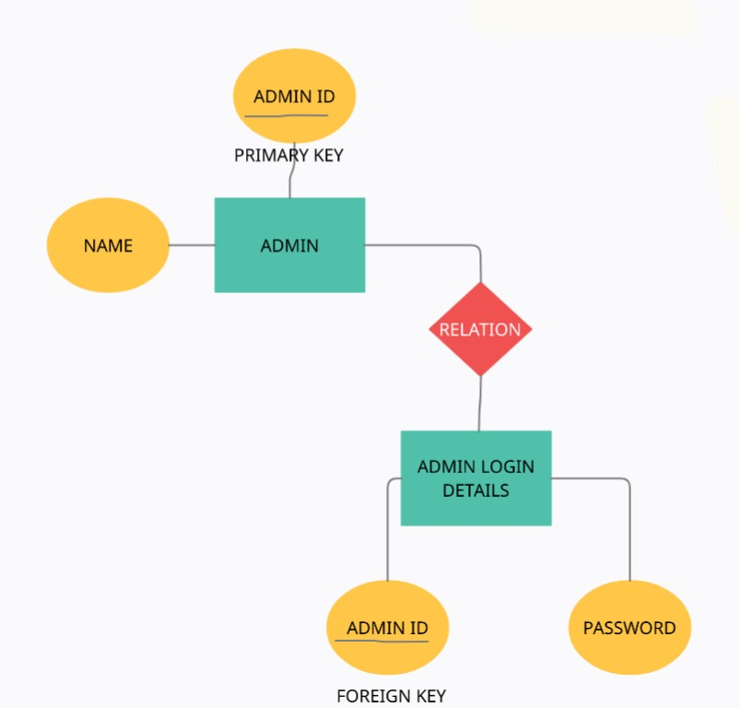

fig 3.1 Admin table ER Diagram

### Customer Table ER Diagram:

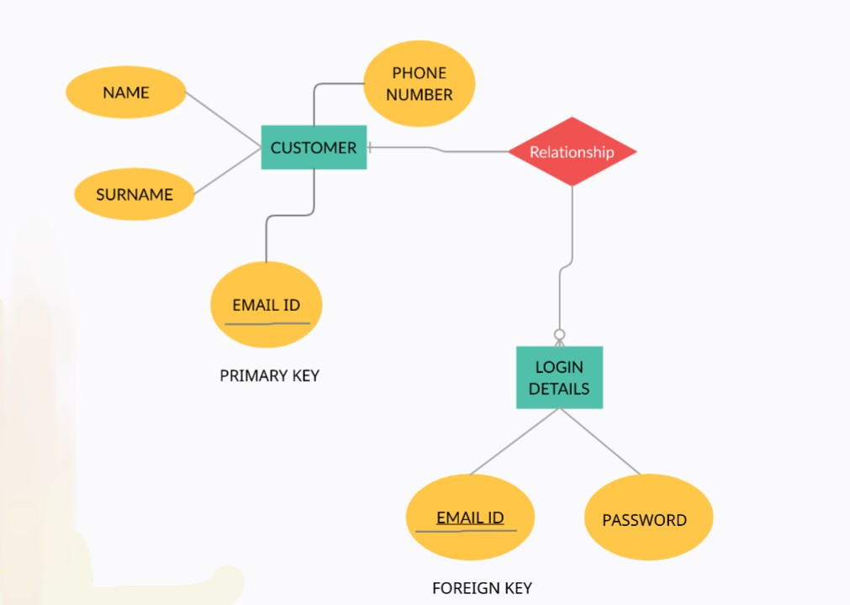

fig 3.2 Customer Table ER Diagram.

### Primary Keys and Foreign Keys

In the Customer table, there is one Primary Key and Foreign Key, i,e. Email ID. In order to login as a Customer they must use their Email ID and password.

In the Admin table, there is one Primary Key and Foreign Key, i,e. Admin ID. In order to login as a Customer they must use their assigned Admin ID and password.

### Relations:

The Admin table and admin login details are related by sharing Admin ID field as foreign key.

The Customer Table and Login Details tables are related by having Email ID from Customer table as a Foreign Key in the Login Details table.

# 7 Future Enhancements

In future, we can expand the scope of this program from rental rates to purchase rates and make the webpage available for public usage. The program can be self-sustaining when owners begin posting ads directly to this application. Humans comprehend the differences when they can visually see price, feature differences. Since the program visually represents the seller also, the general public can easily trust a seller based on the number of properties they are selling at any given point of time. The website has a login module, which in future can be used to send alerts to users whenever the website has new information, or a new article is published. Users can also request alerts as and when an apartment is available in a certain location in Bangalore.

## 8 Design / Screenshot

### Code Screenshots:

* + 1. 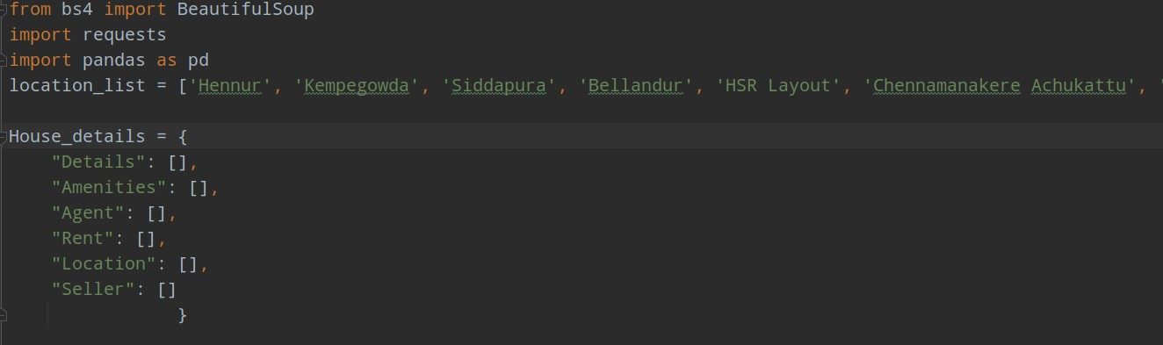Importing libraries and creating dictionaries for storing locations and scraped data.

fig 4.1 Dictionaries for locations and extracted Details.

* + 1. 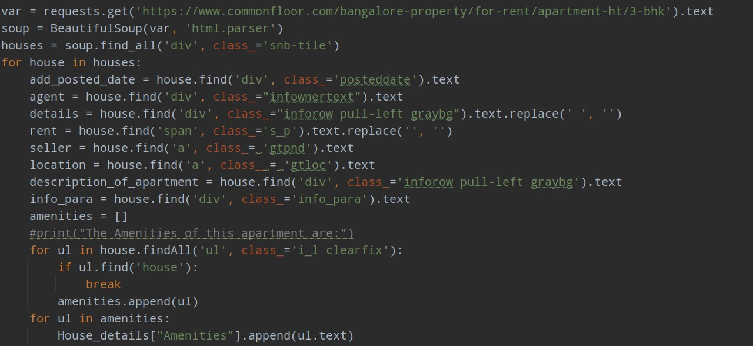Scraping commonfloor.com source code and extracting relevant data.

fig 4.2 Web Scraping.

* + 1. 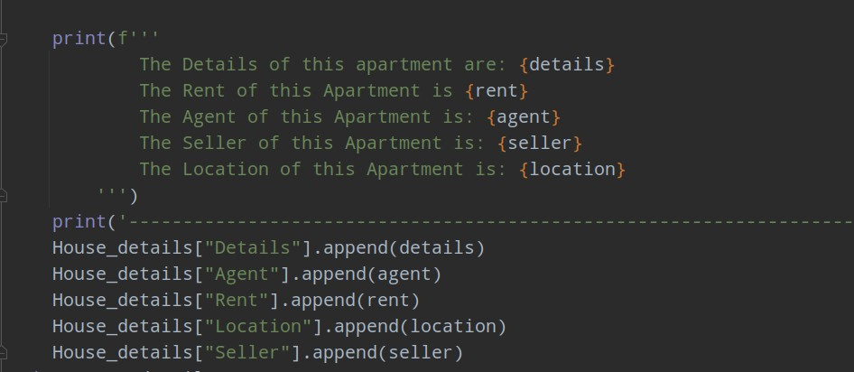Storing the scraped data in House_details dictionary.

fig 4.3 Storing Scrapped Data.

* + 1. 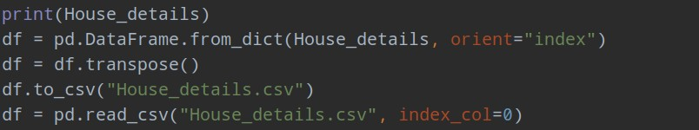Converting House_details into dictionary a pandas dataframe and then to a .csv file for further analysis.

fig 4.4 Dictionary to Pandas Dataframe.

* + 1. 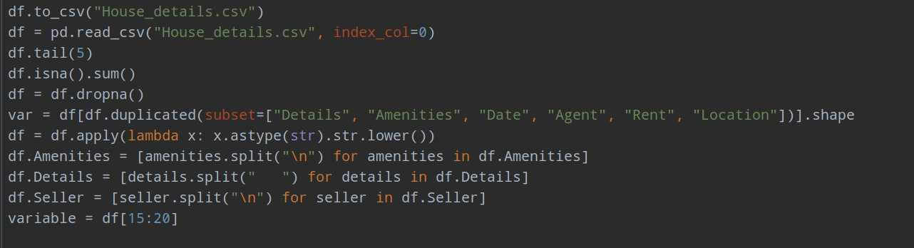Cleaning the data to get an error-free visualization.

fig 4.5 Data Cleaning.

* + 1. 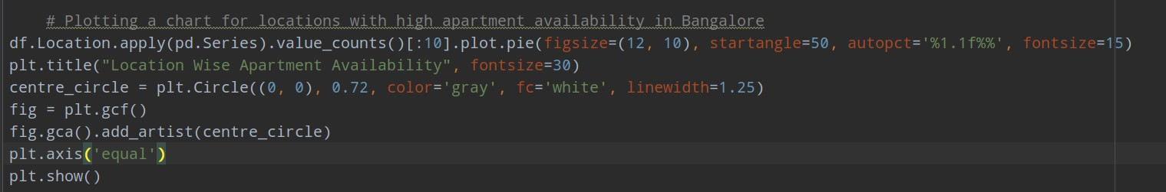Plotting the graph for location wise apartment availability.

fig 4.6 Plotting Graph.

* + 1. 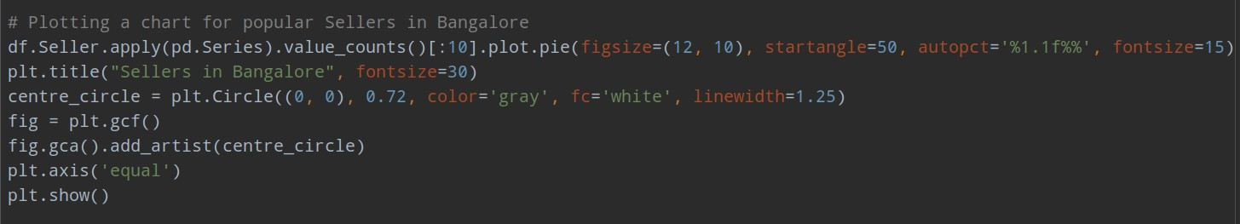Plotting chart for popular sellers in Bangalore.

fig 4.7 Plotting Graph.

* + 1. 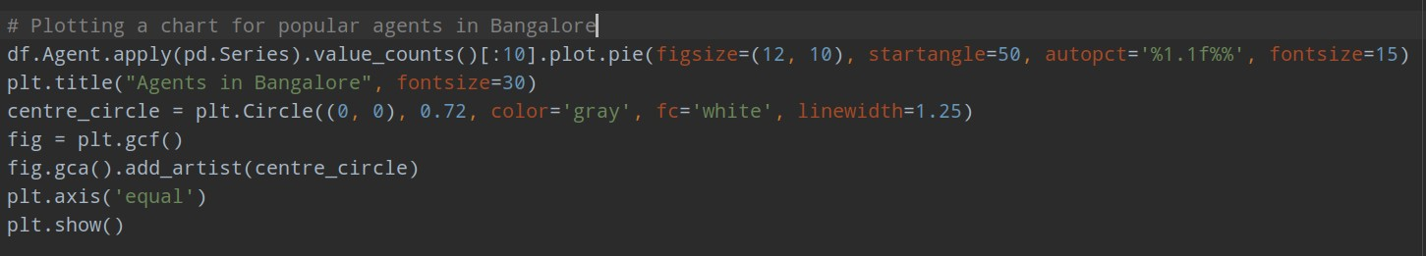Plotting chart for popular agents in Bangalore.

fig 4.8 Plotting Graph.

* + 1. 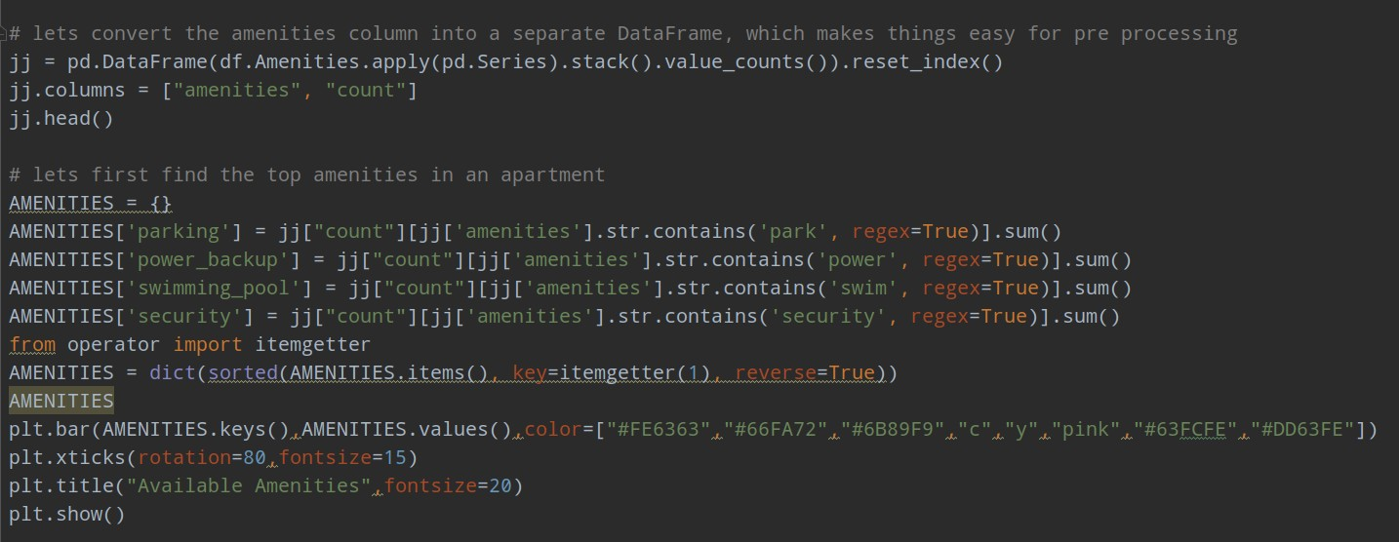A bar graph representing amenities provided by an apartment in Bangalore.

fig 4.9 Plotting Graph.

### Output Screenshots:

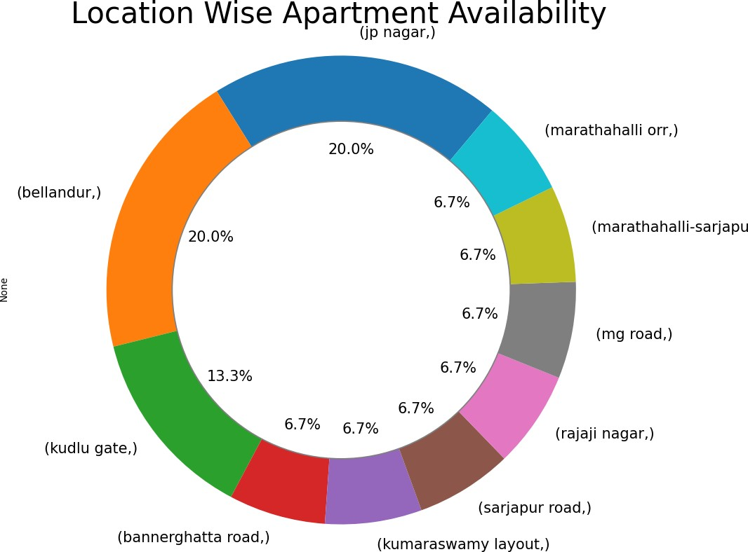

fig 5.1 Location wise apartment graph.

From studying this chart above, it is inferable that it describes the Locations wise frequency of apartment availability in Bangalore. It is clear that JP Nagar and Bellandur share the highest number of apartments available for rent in Bangalore with over 40% of apartments equally divided between the areas. With high apartment availability in this area, one will easily be able to find an apartment that suits their requirements.

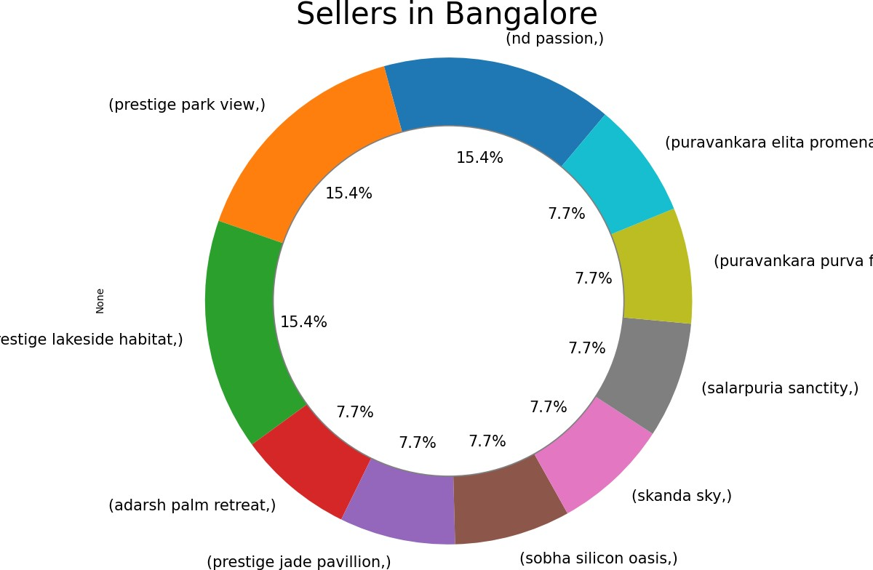

fig 5.2 Sellers Graph.

The Seller Graph suggests that over 38.5% of the seller market is currently dominated by Prestige builders in Bangalore. In second place stands Passion Builders with 15.% market domination. With this chart, travelers can decide whom to approach in search for a quality apartment in Bangalore.

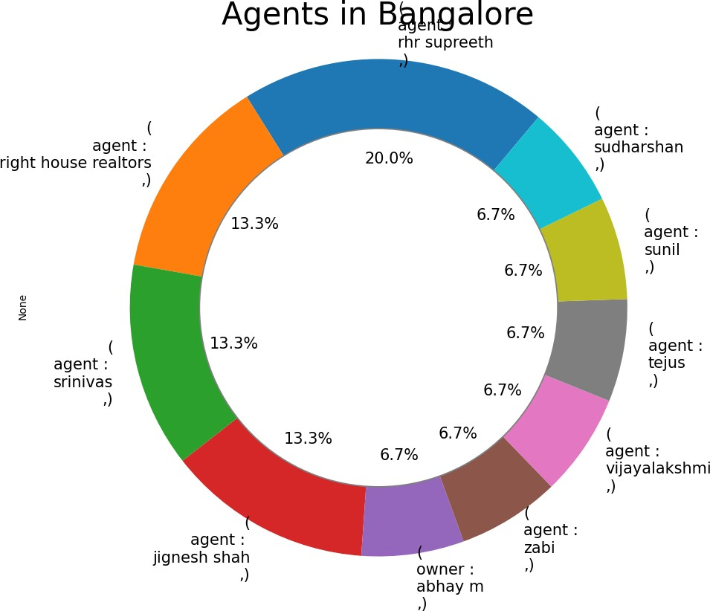

fig 5.3 Agents Graph.

Even if one cannot find an apartment by themselves in Bangalore for various reasons like language barrier or if they want to find an apartment before they’ve arrived, they could approach an Agent. The above chart shows the most active agents in Bangalore. And Supreeth is the most active with over 20% of apartments being managed by him in Bangalore.

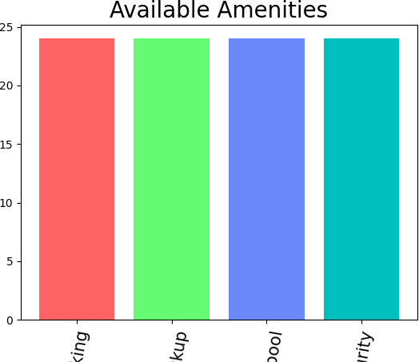

fig 5.4 Amenities Graph.

From the above graph, it is clear that all the listed apartments in commonfloors.com have the four most expected amenities, i.e, Parking, Power Back-up, Swimming Pool and a security Guard. Most of the apartments in Bangalore provide their occupants with these amenities. Although not shown in the chart, some apartments also have gyms.

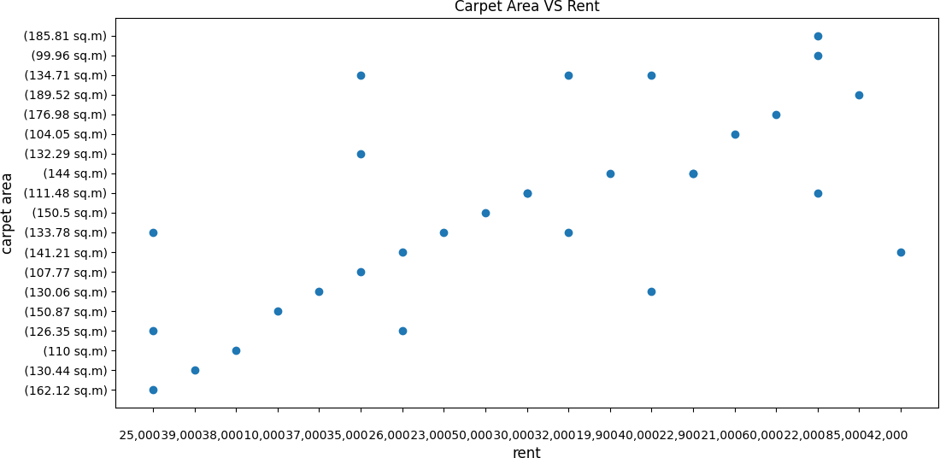

fig 5.5 Rent vs Carpet Area Graph.

By studying this final chart that compares Carpet area against rent of an apartment, it is a linear chart, showing that rent of an apartment increases with increase in Carpet Area. Thus students and bachelors prefer smaller apartments as they would not have to pay large sums of rent.

**9.1 Website Screenshot:**

## 9 Testing

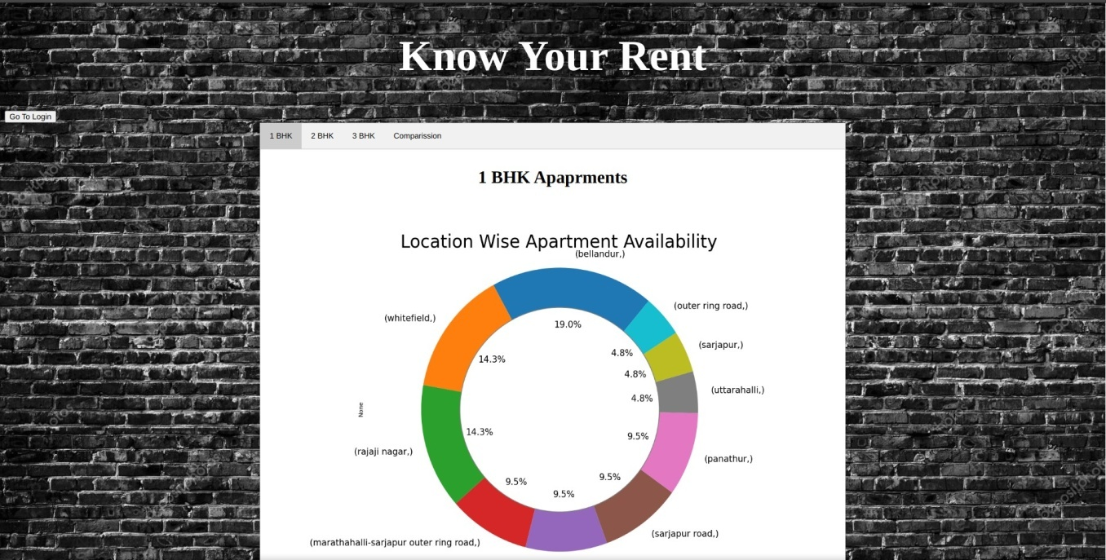

fig 6.1 Web page home page.

The homepage of the website hosts all the visualizations, chart descriptions, comparisons made using the data so that the user can get a better understanding of apartment details in Bangalore.

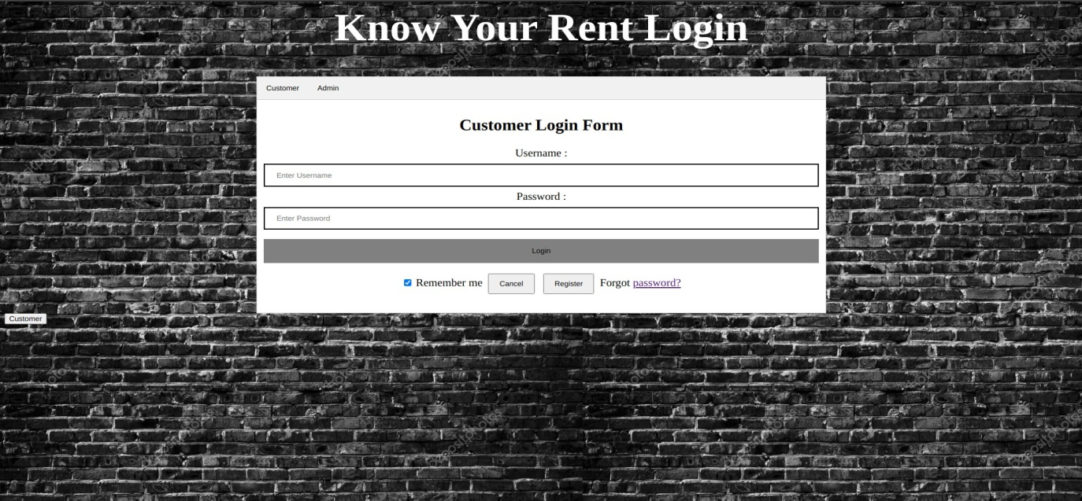

fig 6.2 Login Page.

A registered user will get email notification whenever new data is added to the website. Any functional changes will also be emailed to the registered user.

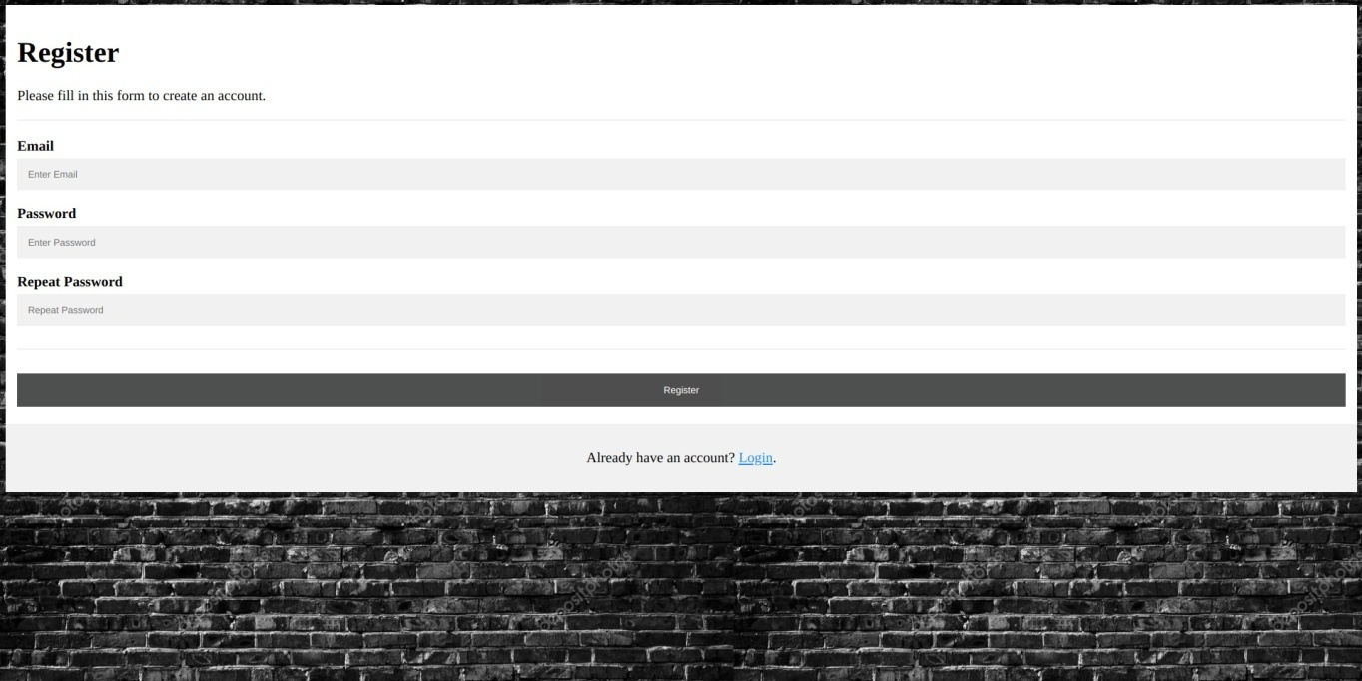

fig 6.3 Account Registration Page.

In future, a new user can register themselves with this website for getting an email notification if and when the data in the site is updated or changed.

## 10 Limitation of System

This Project, like any other, has limitations that we plan to overcome over time. Incomplete Login form:

A new user is not able to register himself as our database connectivity is not functional as of now.

## 11 Bibliography

### 11.1 We sincerely thank

* Dr. Kavitha R for mentoring us for this project.
* Jain University for providing us with an opportunity to showcase what we’ve learnt in the 3 year degree program.
* The judges for patiently listening to us explain the project.